EASY READ APPLICATION FORM
Performance programme

Have you read the Application information?

https://www.coventryshootfestival.com/opportunities
FORM
NAME

POSTAL ADDRESS
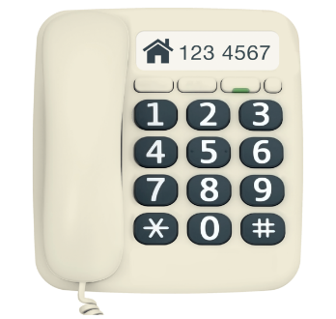

TELEPHONE NUMBER

EMAIL ADDRESS

NUMBER OF PERFORMERS

Write or Record - about you the performer or your group’s work. (Approximately 250 words)

Write or record - about the performance you wish to present at the Shop Front Theatre (Approximately 250 words):

Write or record - What are your technical and equipment needs to perform? (Approximately 100 words):

Write or record - Please provide marketing copy which best describes you and your work. If your music is selected this text may be used to promote your show in our marketing materials. (Approximately 100 words)

HOW TO APPLY Checklist

 | Deadline for application is Friday January 14th at 10am
Have you? | Completed or recorded the application form
 | Filled in the Equal opportunities and Monitoring Form.
 | Sent links for examples of your work
 | Have you sent weblinks or press coverage of your work if you have them?

Email to shootfestival@gmail.com with the subject line ‘Application: Performance Programme 2022’.

You can submit an application by video or audio of no more than five minutes in length. We’re happy to discuss your application and any access needs with you before you apply.

Good luck!

