If you need any of this information in a different format or would like to suggest a different form of application please contact our General Manager, Laura Killeen at laura.killeen@coventryshootfestival.com

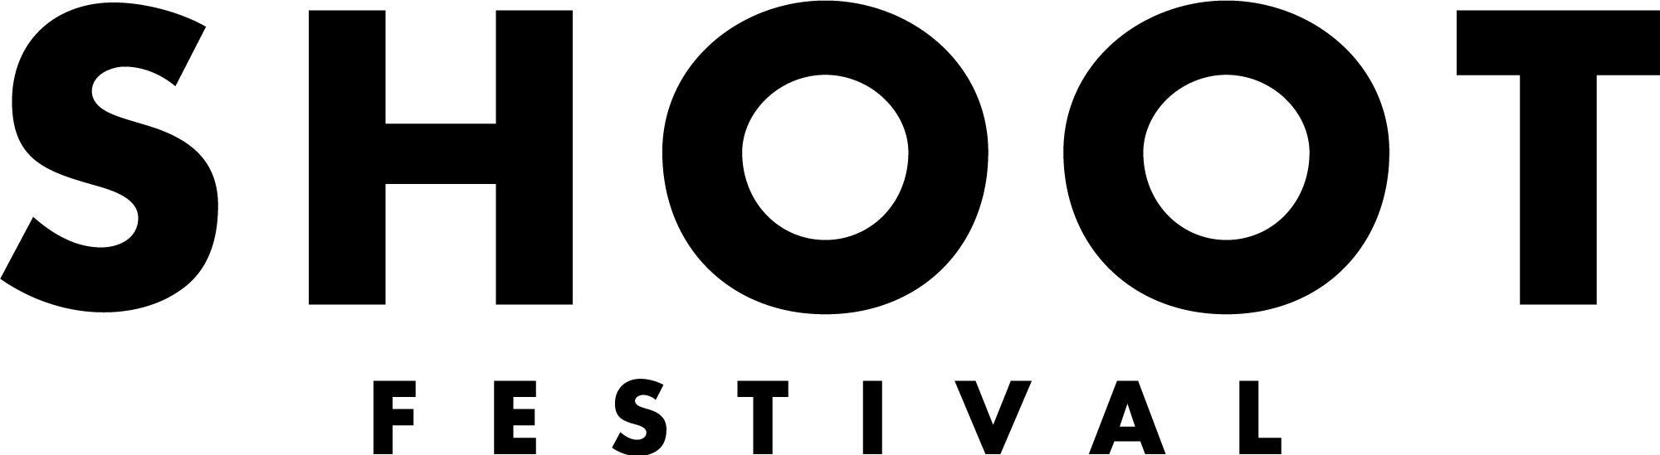

Exhibition Application Form
Saturday 23rd April - Saturday 7th May 2022

It is essential that you read our Application Brief
before applying to Shoot Festival 2022

Each individual artist or group is invited to submit a minimum of up to seven works to be considered. These works must be completed or near completion.

Title(s) of the piece(s):

Group/Individual Name:

Name of primary contact:

Postal address (including postcode):

If your postal address is not a CV-postcode, please indicate your base in a CV-postcode here - this can also include study or work

Email:

Tel:

Number of artists involved:

Please provide us with Artist/Group background (250 words):

Please provide an outline of the proposed work you wish to present at the Exhibition (250 words):

What stage of development is the work currently at? Please include information about previous viewings if applicable (100 words):

What are your technical and equipment needs to exhibit the work? (100 words):

Please provide marketing copy which best describes you and your work. If your work is selected this text may be used to promote your show in our marketing materials. (100 words)

HOW TO APPLY
Deadline for applications is Friday 14th January 2022 at 10am.

Please send your completed application form, Equal Opportunities and Monitoring form and up to seven images of your work, or alternatively weblinks to your work via email to shootfestival@gmail.com with the subject line ‘Application: Exhibition 2022’.

If you do have any additional resources such as press coverage or video footage please send us links or attachments along with your application.

If you would like this application form in an alternative format please contact Laura Killeen, General Manager at shootfestival@gmail.com You can submit an application by video or audio of no more than five minutes in length. We’re happy to discuss your application with you before you apply.

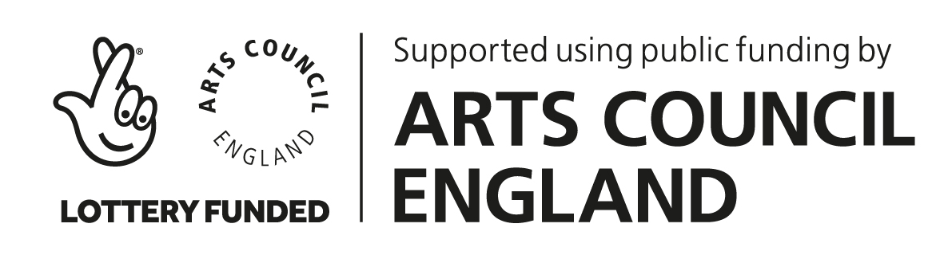
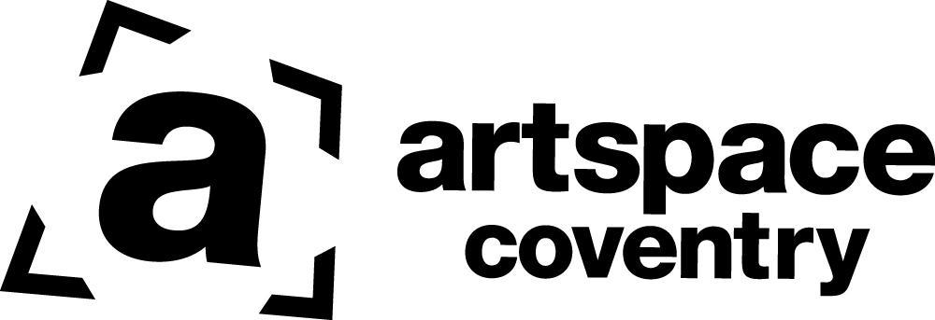
Good luck!

