If you need any of this information in a different format or would like to suggest a different form of application please contact our General Manager, Laura Killeen at laura.killeen@coventryshootfestival.com

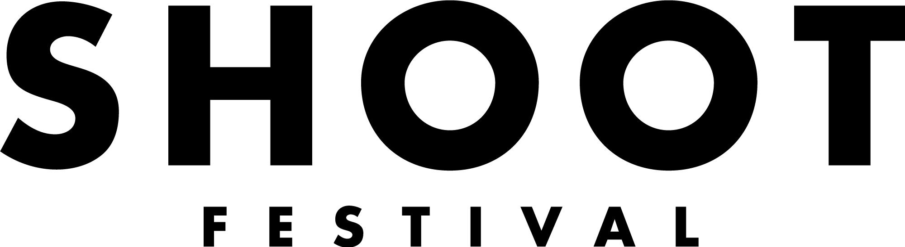

Performance Programme Application Form
Saturday 23rd April 2022 at the Shop Front Theatre

It is essential that you read the Application Brief
before applying to Shoot Festival 2022

Title of the piece:

Company/Individual Name:

Name of primary contact:

Postal address (including postcode):

If your postal address is not a CV-postcode, please indicate your base in a CV-postcode here (this can also include study or work)

Email:

Tel:

Duration of the piece:

Number of artists involved:

Please provide us with Artist/Company background (250 words):

Please provide an outline of the proposed performance idea you wish to platform at Shoot Festival (250 words):

What stage of development is the performance currently at? Please include information about previous viewings if applicable (100 words):

How do you think the performance will fit within the context of the Shop Front Theatre venue (100 words):

Please provide marketing copy which best describes you and your work. If your performance is selected this text may be used to promote your show in our marketing materials. (100 words)

HOW TO APPLY
Deadline for applications is Friday 14th January 2022 at 10am.

Please send your completed application form, Equal Opportunities and Monitoring form and three images of your work or images that represent your work to shootfestival@gmail.com with the subject line ‘Application: Performance Programme 2022’.

Although we appreciate that not all artists will have a website or online content, if you do have any additional resources such as press coverage or video footage please send us links or attachments along with your application.

If you would like this application form in an alternative format please contact Laura Killeen, General Manager at shootfestival@gmail.com

Good luck!
