EASY READ APPLICATION FORM
The Exhibition

Have you read the Application information?

https://www.coventryshootfestival.com/opportunities
FORM
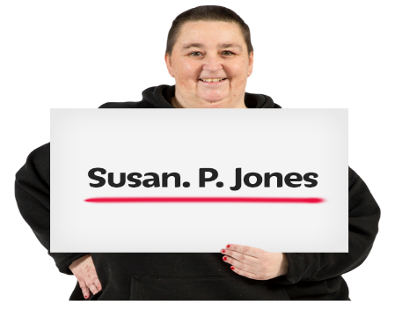
NAME

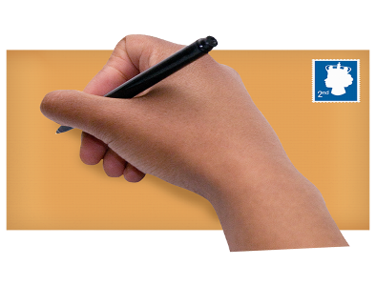
POSTAL ADDRESS
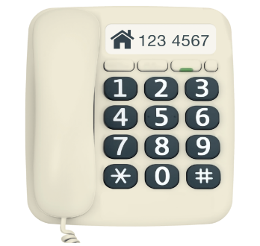

TELEPHONE NUMBER

EMAIL ADDRESS

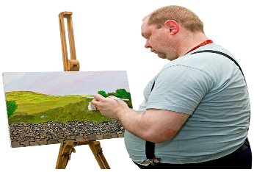

NUMBER OF ARTISTS

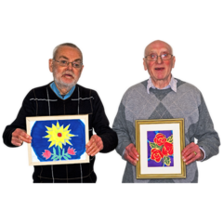  WHAT IS THE ART CALLED? | 1,  2.  3.  4.  5.

Write or Record - about you the artist or your groups work. (Approximately 250 words)

Write or record - about the work you wish to present at the Exhibition (Approximately 250 words):

Write or record - Is your work finished? Has it been viewed anywhere ( Approximately 100 words):

Write or record - What are your technical and equipment needs to exhibit the work? (Approximately 100 words):

Write or record - Please provide marketing copy which best describes you and your work. If your work is selected this text may be used to promote your show in our marketing materials. (Approximately 100 words)

HOW TO APPLY Checklist

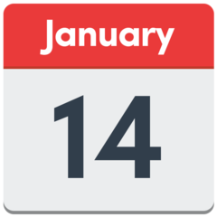 | Deadline for application is Friday January 14th at 10am
Have you ? | Completed or recorded the application form
 | Filled in the Equal opportunities and Monitoring Form.
 | Sent links for up to 7 images of your artwork
 | Have you sent weblinks or press coverage of your work if you have them?

Email to shootfestival@gmail.com with the subject line ‘Application: Exhibition 2022’.
You can submit an application by video or audio of no more than five minutes in length. We’re happy to discuss your application and any access needs with you before you apply.

Good luck!

