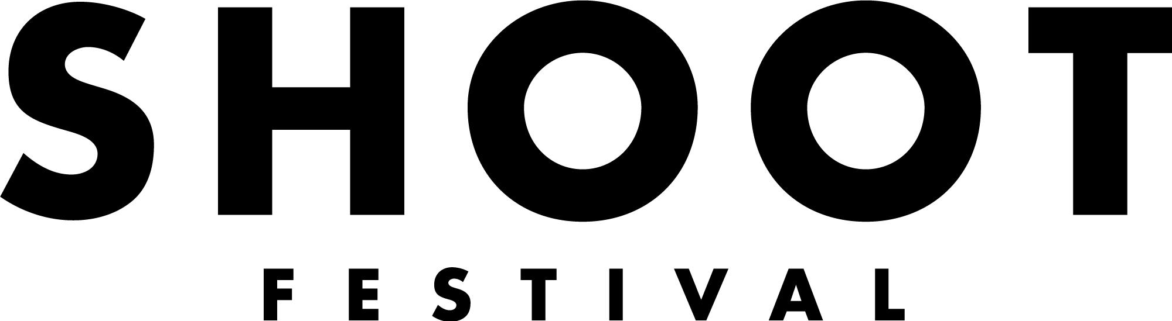
If you need any of this information in a different format or would like to suggest a different form of application please contact our General Manager, Laura Killeen at laura.killeen@coventryshootfestival.com

An Easy Read Call out – The Performance Programme
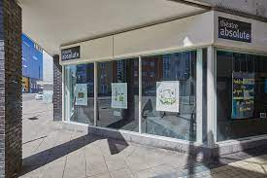 | The Performance Programme is a day long event for nine emerging artists and/or companies to show their work in Coventry.  The Performance Programme will take place at Theatre Absolute’s Shop Front theatre alongside our Sound Stage, workshops and Visual Arts Programme  We are looking to programme a diverse range of performances celebrating the best of Coventry and Warwickshire talent.
The performance will happen on Saturday 23rd April 2022.

The Festival also includes The Exhibition, Workshops and Sound Stage.

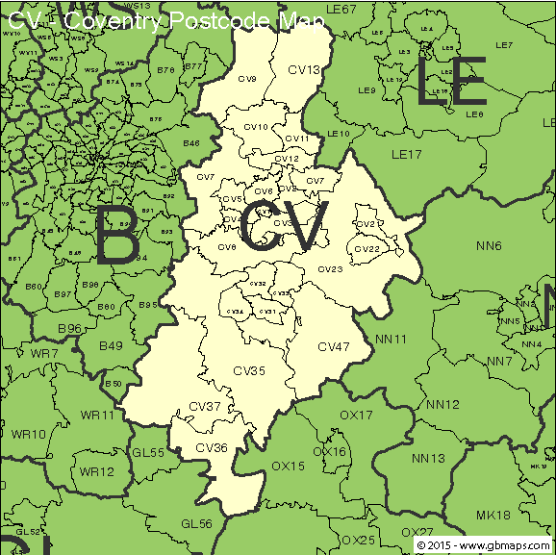  18+  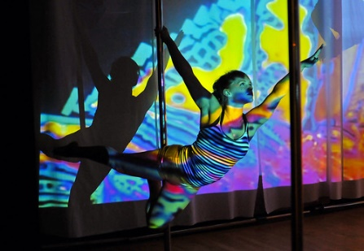  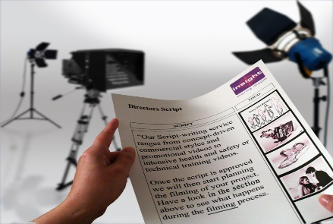  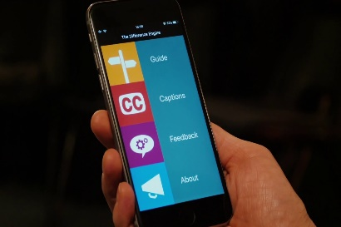 | It is only open to artists that live, work or study in Coventry or Warwickshire – You must have a CV postcode.  You must be aged 18+  An emerging artist is used broadly.  You might be established but want a local connection or this could be your very first exhibition. We would like anyone who could benefit from this opportunity to apply.  We are looking for exciting new and original work – All live Art forms.  This could be -  - Devised work  - New writing  - Or adaptations of existing material.  - It can be :  Theatre  Dance  Solo performance  Spoken Word  Performance Poetry  Or anything in between  You will be asked to make work accessible by using The Difference Engine – new tool making events accessible. You will get help with this.  https://differenceengine.talkingbirds.co.uk  For performances to also be BSL interpreted.
What we can offer you

£125 fee for every artist chosen

Opportunity to perform your work in a professional venue in front of an audience made up of local people, Industry professionals and fellow artists.

Help – Full technical support.
Rehearsal space (where available).

A chance to meet other local emerging artists.

Photography and filming of your performance.

The chance to win our Artist Development Award worth £1000 - £500 to the artist and £500 in mentorship or development.

Technical Information - Tech Support we can help with:

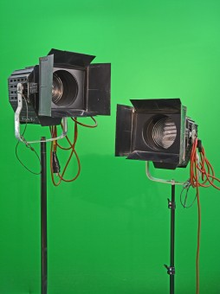 | Basic lighting set up
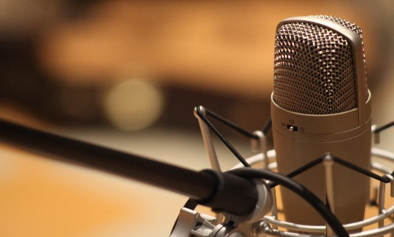 | Microphones
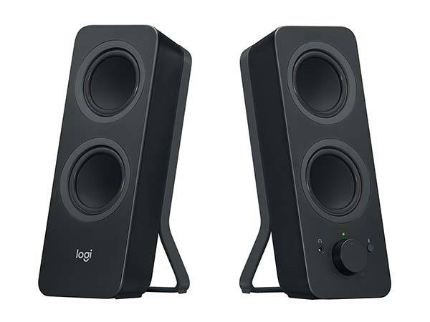 | PA System and Speakers
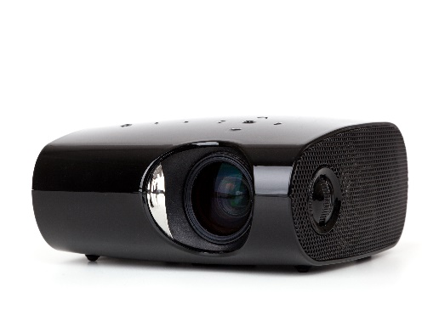 | Projection
 | If you want to bring any of your own equipment you can but it must be PAT tested

The Plan of The Shop Front Theatre
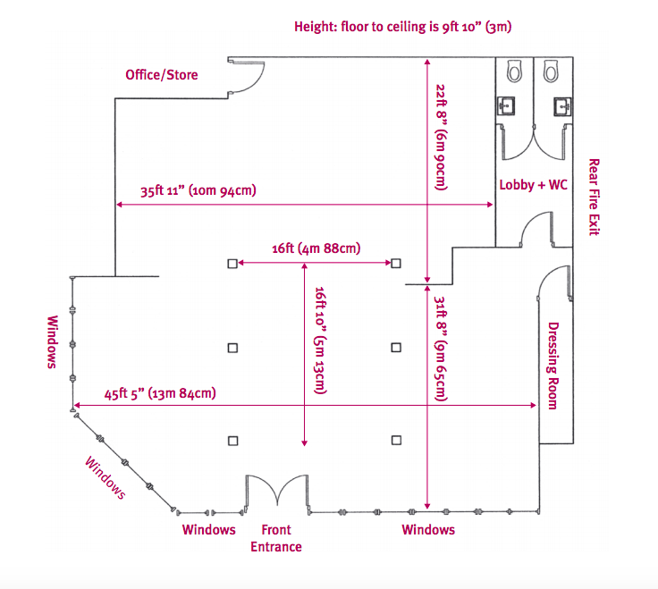
- The space is adaptable and can be moved to fit any audience position and performance location although please be aware that turnarounds between performances can be as short as 5 minutes - this will be discussed at the production meeting. You can find out more about the space here: http://www.theatreabsolute.co.uk/shop-front-theatre/

- The space at The Shop Front Theatre can be used in different ways. It seats 55 people.

- There is no lighting rig. Lighting is on stands.

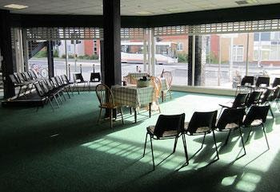
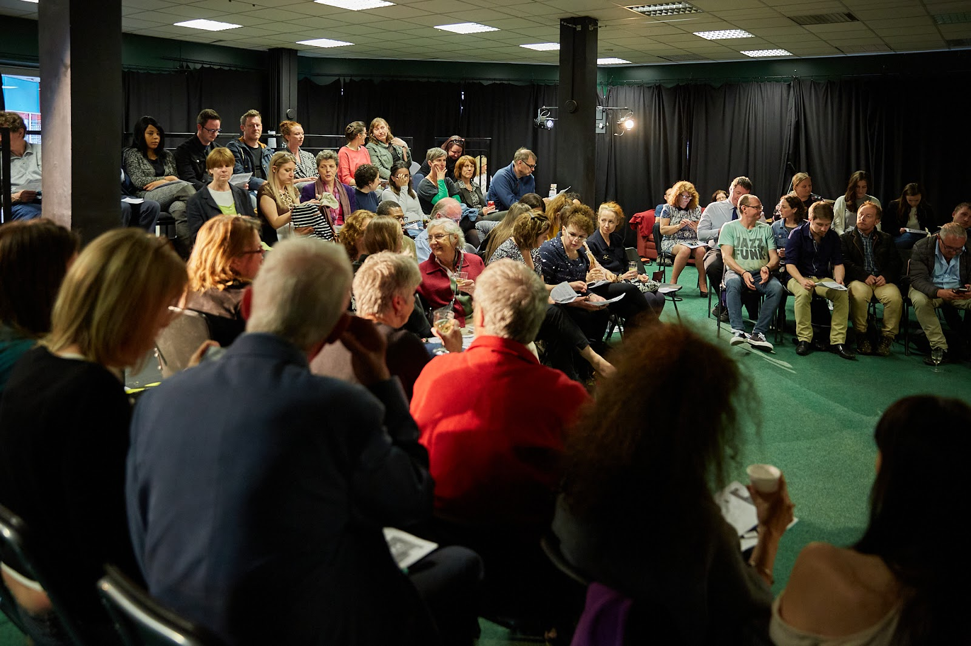

Selection Criteria
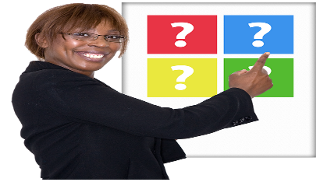 Shoot Festival Co-Artistic Directors and representatives from Coventry Artspace make the final selection.
Entries will be considered against these:

- What your performance proposal is and the quality of it.

- It must be your own original work.

- It must be achievable in the Shop Front Theatre. That it is not a traditional theatre space.

- How it will help you to develop as an artist.

- The work must be “live” or include “Live” elements.

- Special credit will go to applications that use the space in a creative was although this is not essential.

- You must live, work or study within Coventry or Warwickshire.

- There will be a risk assessment of the work to make sure its meets Health and Safety and is suitable for diverse audiences.

How to Apply -
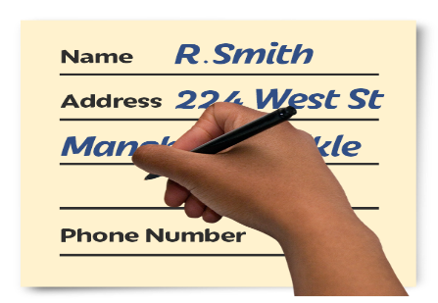 | Deadline for applications – Friday 14th January 2022 at 10am  Fill in form - https://www.coventryshootfestival.com/opportunities  or submit video that is no longer than 5 minutes in length,  or apply in an accessible way to meet your needs. If you need help or support applying contact - shootfestival@gmail.com  Check list for application.  - Fill in your personal information  - Answer the questions.  - Send up to 3 links to your work  - Send links to any additional press coverage or video footage if you have them.  - Fill in and send the Equal opportunities and Monitoring form.  - If you know you have technical requirements let us know.  Email to shootfestival@gmail.com with the subject line Application: Performance Programme 2022
What you will need to do if selected -
Date to be confirmed | Attend a production meeting
Between Monday 18th April and Friday 22nd April 2022 | Attend a technical rehearsal during get-in week.
Saturday 23rd April | Perform at The Shop Front Theatre

Any questions or access support to complete your application please contact shootfestival@gmail.com

